Stages of the Dark Night – Notes from MCTB2

5. Dissolution, Entrance to the Dark Night

- Stages five through nine tend to come as a package, with one stage leading fairly quickly and naturally to the next. Stage ten, Re-observation, tends to stand out as its own distinct and often formidable entity, like the icing on a very creepy cake.
- Dark Night typically begins with just about all the profound clarity, mindfulness, concentration, focus, equanimity, and bliss of the A&P dropping away. This is one of the hallmarks of Dissolution.
- It doesn’t matter if we practice from this point on; once we cross the A&P, we are in the Dark Night to some degree.
- If we do get through it without getting to the first stage of enlightenment, we will have to go through it again and again until we do.
- There are two basic challenges that occur during the Dark Night: one emotional, the other perceptual. The emotional challenge is that our most disturbing and difficult psychological issues tend to come bubbling up to the surface with an intensity that we may never have known before.
- Our reactivity in the face of our dark stuff can cause us and those who must deal with us staggering amounts of needless suffering.
- The perceptual challenge is that we also begin to experience directly the fundamental suffering of duality, a suffering that has always been with us but which we have never recognized with this level of intensity [...] We face a profound and fundamental crisis of identity as our insight into the three characteristics begins to demolish part of the basic illusion of there being a separate or permanent “me”. This is a kind of suffering that has nothing to do with the circumstances of our life and everything to do with a basic misunderstanding of all of it.
- In short, some of the Dark Night stages can feel like we are up serious shit creek without a paddle and headed immediately over the waterfall.
- The frequent knee-jerk response is to try to make our minds and our world change to try to stop the suffering we are experiencing.
6. Fear

- Fear can involve all sorts of frightening distortions of perception when sitting, accompanied by intense feelings of unease, paranoia, terror, dread, and/or “the willies”. It can even sometimes seem that our body is falling in tatters through the floor or that we are rotting away.
- The degree of fear that people experience in Fear can vary quite widely. Some people can suddenly experience extremely powerful feelings of abject terror for no obvious reason at all, but the mind has this odd tendency to create stories to explain how we are feeling, to fabri-cate things to be suddenly afraid of, even if those explanations and rationalizations are notthe cause at all and arose after the fact of the terror setting in. Just feeling terror without anobject can be very disorienting.
- Nightmares are substantially more common in this stage.
7. Misery

- Misery is characterized by intense feelings of sadness, grief, and loss. There can be enormous grieving in this process.
- Energy, which may have increased a bit in Fear, may flag again during this stage
- Concept of self and the world as being permanent, able to satisfy, and even being “me” or “mine” torn up from the roots.
- The feelings that Misery can bring up are hard to accept for many, and our resistance to this process causes us further misery. Just as with Fear, it is common to come up with fabricated reasons to be miserable after the misery has already set in, a tail wagging the dog type of thing.
8. Disgust

- We begin to feel completely tormented by our noisy and repetitious minds. By a body that is full of suffering and unpleasant sensations, and by a world that is falling apart, as well as an image of ourselves, that, while seemingly growing tighter and tighter in terms of how it feels, is also paradoxically becoming more volatile, fragmented, and unstable.

- Perceiving thoughts as thoughts becomes harder and harder. Gone is the freedom that the insights of Mind and Body allowed us, though they tend to return later in Equanimity.
1[...] we can intentionally remember to see thoughts as thoughts, and it can be very helpful in this stage to note “thinking” when we have harsh thoughts.

- It is a stage at which it is very easy to be very critical of basically anything, another case of the tail wagging the dog, in that the mind state of Disgust comes first and we then apply it to our outside world not realizing that we just did that, judging things and people harshly due to being at this stage

- Many in Disgust will find that basically anything but the “highest and best” will annoy the crap out of them.
9. Desire for Deliverance
- At the stage of Desire for Deliverance, we are fed up with basically everything
- By some weird trick of this stage, it can be very hard to imagine that we are close to great stages of practice from this vantage point.
- We can feel that, if we just go far enough out or in, we can get to something better, and the pull towards that nebulous but powerful, imagined “better” can be very strong at this stage.
- Often this pulling feeling has a stronger component to it of running away, meaning that it can feel more like we are fleeing unpleasant things rather than being called to salvation.
- In this stage, it is easy to identify with their [historical figures] stories and the feeling that we are similarly “called out” of our comfort zones and to something greater, farther, higher, or at least less bad.
- If you find yourself working on your escape plan, try to re-channel that into your inscape plan, such that you can turn attention within at the actual root of the problem in your own heart, mind, and body.
- ...honestly feel that crash, that utter devastation, that agony, that bottoming out, that despair, that longing for release, in all its down-to-earth, real, gritty humanity, allowing that plunge to happen inside you deep down, down, down. Then, investigate that, just as it is [...] So, fall. Notice it. Allow it to be. Notice it is made of sensations: feel them honestly, as well as all the reactions to those sensations. This is the key.
- ...off the cushion, do not do anything stupid, which is to say destructive of yourself or anything else. ‘Don’t fuck up!’
- Somewhere in here, there can arise the tendency to try to get our lives and finances in order so that we can leave the world behind for a time and have something to come back to without having to worry about such things for a while.
10. Re-observation
- Bodily sensations of creepy revulsion, disgust, or profound existential angst may arise...
- This stage is often, though not always, like a brick wall, particularly the first few times we collide with it.
- Re-observation is all fluff and no substance. It is like a toothless dog with a ferocious bark. It is like a hologram of a snarling demon that you can just walk right through and it can’t touch or harm you at all. There is a curious freedom when you deeply realize that you are safe in Re-observation, that you can go deep into the pit, and the pit is just fine.
- Re-observation can take whatever issues and reactions arose in the earlier stages,[...]combine them in fiendish ways, and then crank that intensity to the next level, a level that can seem overwhelming.
- Beware of making radical life changes that cannot be easily undone[...]based upon the temporary feelings that may arise during this stage
- When in Re-observation you may think, “This totally sucks! Dang, I really want to get to Equanimity!” Feeling into that yearning, being very clear and honest about how you are feeling and thinking, as well as just continuing to practice, makes it all happen.
- We may get the sense that we have never had such a strong emotional life, and until we get used to this new awareness of our previously subtle or unacknowledged feelings, this stage can seem overwhelming.
- Go into them,[intense feelings] but with wisdom, with clear morality, with some sense that you can go there and be okay, with some control of what you think, say, and do.
- The classic arc of the hero’s journey, where at some point they must enter the underworld, mirrors this part of the path. Part of the flip side of the next stage involves going there, being honest, dealing with an utterly “un-spiritual” way of being that might not fit your ideals at all.

11. Equanimity
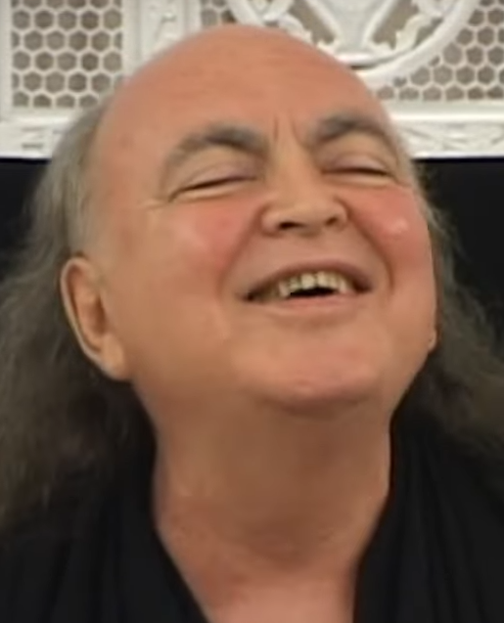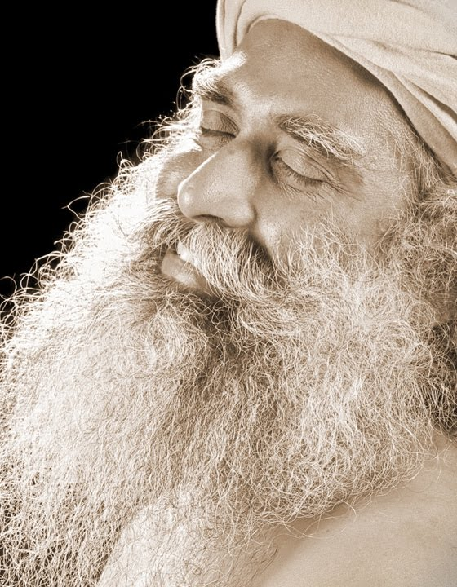

- Equanimity is much more about something in the relationship to and among phenomena than anything specific about the phenomena themselves. It involves a real, down-to-earth, honest humanity, a real acceptance of ourselves just as we are.
- Figuring out how to manage the transition from Re-observation to Equanimity is one of the big keys to practice.

Things that can help
- Physical excercise.
- Yoga with a high degree of bodily awareness, as that can ground people in something other than their psychological stuff.
- Loving-kindness practices and other brahma viharas
- Strict vipassana and ultra-rapid noting work well for those with a high tolerance for pain. Slower noting might work for those with a bit more time and less interest in shattering themselves.
- Psychological healing, therapy, “with a high degree of sensate mindfulness of that process to ensure it keeps producing insights.”
- The “concentrate your ass off” strategy in the Dark Night has much to recommend it.
- Some find that softening, opening, and accepting generate much better results than more aggressive approaches such as rapid noting or surfing fine vibrations.
- One thing that can help in the midst of a can't-be-stopped mental drama is just raise a finger of one hand. Basically, you let the whole thing play out but you remember that it's a mental drama... and if you forget, you look down at your hand and you see the finger raised. "Oh yeah..." /Shargol

Notes from Shargol’s post compilation:

- Here's what you need to keep in mind: in the dark night, dissolution, fear, misery, disgust, a desire for deliverance, and a freak out mind are all likely to occur ---- as mind states. You are basically being shown a movie of all of your hang ups, your shadow, your history. It's not because you are bad or flawed or unworthy. It's because your mind really does want to digest this old material and move beyond it. There is no way to move through things like trauma or PTSD or Dark Night without going through some difficult mind states. It's simply the nature of healing.

- A last point: as developing humans, we can become very paranoid about these difficult mind states because we don't see the good in them. Why on earth should we sit on the cushion and go through all of this? What does it get us?

- All these difficult mind states will also have a piece of wisdom connected to them, sort of hidden within the noise. There is a >positive intention< that is within each state:
- Fear just really wants to keep us safe.
- Misery really wants the world to be more fair and just.
- Disgust really wants us to make better choices and care for ourselves.
- Desire for Deliverance really wants us to work carefully toward improving.
- Reobservation really wants to give us a guided tour of all of our silly trigger thoughts/feelings so that we see that freaking out isn't helpful.

- Effort is fine and good, but there is a limit to what you can "make happen" on a retreat. The big difference between a dark night yogi and someone who reaches SE is the ability to become intimate with what is occurring in experience, but without struggle or striving --- this is equanimity.

- The dark night stages are a time when we need to continue to welcome all the dark stuff in our psyche to come out, but to do so in an intelligent and adult way. We need to welcome the laziness, fear, misery, disgust, and frustration into our meditation ---- and study it! What does it feel like when we have these feelings, what thoughts are associated with the feelings, why are these states so seductive and powerful? How does greed, aversion, and indifference work during these feelings/stages? How do our emotions keep us trapped in samsara?
- The mind is MUCH MUCH MUCH smarter than we are. All we need to do is pay attention to what naturally arises on retreat. Simply doing this for 16 hours a day while walking, sitting, shitting, peeing, eating, and bathing is more than enough to give you the necessary centering and relaxing to reach SE.
- There can be a lot of guilt and shame that also arises when we face our old material, shadow self, and past history. Again, this is not because you are bad or flawed or unworthy. It is because the mind wants to protect itself and avoid stuff until it can move through it.
The nature of mind is such that it wants to be safe AND it wants to heal. Healing involves going into those yucky sensations, awkward emotions, and oppressive thoughts with mindfulness, appreciation, friendliness, caring, and acceptance. When you go through these mind-states with awareness you realize that they are old baggage, not relevant, weather that is here now and gone later, not the same as the Self, transitory. You also can connect to the witnessing/aware mind that SEES all of this. This is what develop the more adult and sane mind that is resilient.
- The normal human progress for developing resiliency is:

(1) First we are only stable when the body and mind is stable,
(2) Then we can be stable when the body is freaking out but the mind stays clear,
(3) Finally we are so grounded in the Self that we can be stable when the body and mind is freaking out.

Quotes from random places:
Dukkha nanas. So this is a stage in Vipassana practice that is characterized by negative mental emotions. You usually clearly see impermanence everywhere and this triggers the emotions.

